Test your Knowledge: High Level Design

Hillsborough community college

10/10/2021

|  |  |
| --- | --- |
| Version No. | 1 |
| Authorized by | NA |

Introduction

* 1. **Scope of the document**

This document will outline the high-level function design of *‘Test your Knowledge’*. It will highlight the high-level flows/ use cases and design of the components. It serves as an input to the low-level design that will further elaborate on the design.

* 1. **Intended audience**
* Entry level programmers
* Intermediate programmers
* Advanced programmers
* Highschool students
* College students
  1. **System Overview**

This Application will provide real time feedback about where you stand with your standard knowledge of programming. It will have an overview for a few different disciplines of programming such as;

* Javascript
* Python
* PHP
* SQL
* C
* C++
* C#

System Design

**2.1 Application Design**

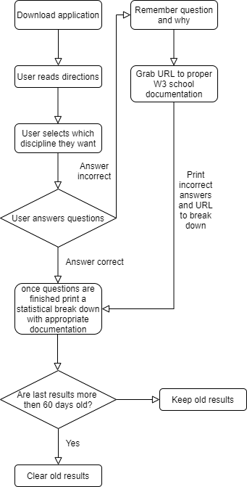

**2.2 Testing framework**

The testing framework that I will be using is going to be the keyword driven testing framework. Because this is such a small project, I believe this framework is the best way to go about testing my different variables and functions.

**2.3 development/build environment**

I will be using maven for dependency management as it is the most widely used resource. Git will be used for version control because I have just recently learned how to use this and would like to incorporate it into a program.